Planning Advisory Service (PAS) report May 2019

Purpose of report

For information.

Summary

This is the first time that PAS has reported to the EEHT board. PAS is a programme of work providing support and advice to councils on planning issues, paid for and directed by MHCLG.

This paper sets out a review of the year 2018-19. The lead officers will also make a short presentation to members which will cover some of the work underway in 2019-20 and to answer questions.

Recommendation

That members note the report

Action

Officers to take forward any member suggestions to improve the report

Contact officer: Anna Rose

Position: Head of PAS

Phone no: 07768020397

Email: anna.rose@local.gov.uk

Planning Advisory Service (PAS) report May 2019

Background

Governance

1. The IDeA receives a £1m grant each year to provide the PAS programme of advice and support to councils. The work is directed and managed at monthly liaison meetings between MHCLG and PAS officers.
2. For many years PAS had its own board formed of 4 EEHT members and 5 external advisors. At the IDeA board meeting in September 2018 it was agreed that this board be discontinued and in its place PAS would report twice-yearly directly to EEHT.
3. The purpose of these reports is to provide members with an update on the work of the programme, to share any emerging issues or learning and to ask for member’s advice and guidance.

Key Facts & Figures

1. PAS has an annual grant of £1m. Alongside this grant there is a separate one-off grant of £400k to provide strategic planning support and various commercial activities of just over £100k.
2. There is currently a team of 7 employed on a mixture of permanent and fixed-term contracts.
3. The work is done using the principles of sector-led improvement and uses many LGA-wide models of delivery (eg Peer Challenge and Leadership Essentials) but scoped more narrowly on planning, housing and delivery.

**Review of 2018-19**

Highlights of the year

1. Each year is slightly different and 2018-19 was a very busy year full of new things. That meant that we did lots of events to help people engage and understand the reforms, and preparing some tenders and commissions to procure support for more detailed follow-up work.

.

1. For the first time ever we had two iterations of the [National Planning Policy Framework](https://www.gov.uk/government/publications/national-planning-policy-framework--2) - the first in July 2018 with some minor updates in February 2019. This has led to two support offers (currently in pilot):
   1. Councils must now review their plans within 5 years of adoption to assess whether they need updating [[para 33](https://www.gov.uk/guidance/national-planning-policy-framework/3-plan-making)]. We hope to establish how this review process might work, to avoid significant cost or a process that undermines the long-term outlook of a local plan.
   2. While the concept of proportionality is not new to plan-making, this more frequent review process and the way in which housing evidence is changing means that we are going to revise and improve [our advice on evidence](https://www.local.gov.uk/pas/pas-support/plan-production/plan-making-direct-support/plan-making-direct-support-review-your).
2. Alongside the NPPF we also had the introduction of the [Housing Delivery Test](https://www.gov.uk/government/publications/housing-delivery-test-2018-measurement). Originally scheduled for November 2018 it was actually published in February 2019. This applies a monitoring regime to the delivery of housing and creates a series of sanctions for failing the test. We worked with a number of pilot councils to [prepare guidance](https://www.local.gov.uk/pas/pas-topics/monitoring/preparing-effective-action-plan) and technical support and are now working with the first cohort of 108 councils.
3. Strategic planning (ie using strategic planning policies across broad areas that often reflect functional geographies like city regions) has started to happen in several areas. Keen to encourage this “bottom-up” approach MHCLG suggested that we apply for some [Planning Delivery Fund](https://www.gov.uk/government/publications/planning-delivery-fund-prospectus) money to allow us to scale up and intensify our support. In September we were successful in applying for £410k to support five places and produce three topic papers.

Financial

1. A basic part of delivering the programme is to get maximum benefit for councils from the grant which is a maximum of £1m. This year we were unusually close at 99.6%

|  |  |  |
| --- | --- | --- |
| Quarter | Forecast | Actual / notes |
| Q01 | £180 | £159k submitted |
| Q02 | £230 | £221k submitted. |
| Q03 | £230 | £251k submitted |
| Q04 | £360 | £365k submitted |
| Total | £1000 | £996k |

1. This overall figure is an excellent result. To achieve this the initial work programme agreed was varied to respond to changing timetables and shifting policy priorities.
2. Each year we have a separate audit to ensure the grant conditions are satisfied. In July 2018 we learned we had a clean audit for the previous year.

Engagement, reach and quality

1. The quality of work remains truly outstanding as tracked by our use of delegate feedback forms

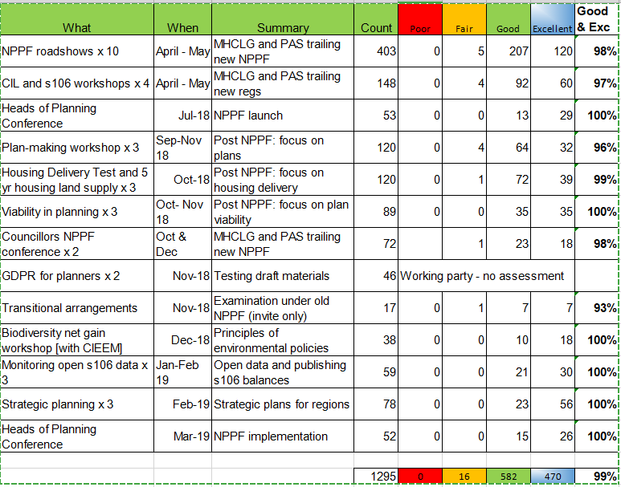

1. Our target for events is 90% good & excellent. Our overall result for the year is over 99%.
2. Many of our events were supported by officials from MHCLG and this kind of direct engagement was extremely popular with delegates.
3. We track where delegates come from to ensure we are hitting our target audience. Black is “no show” and the scale purple through yellow shows increasing attendance.

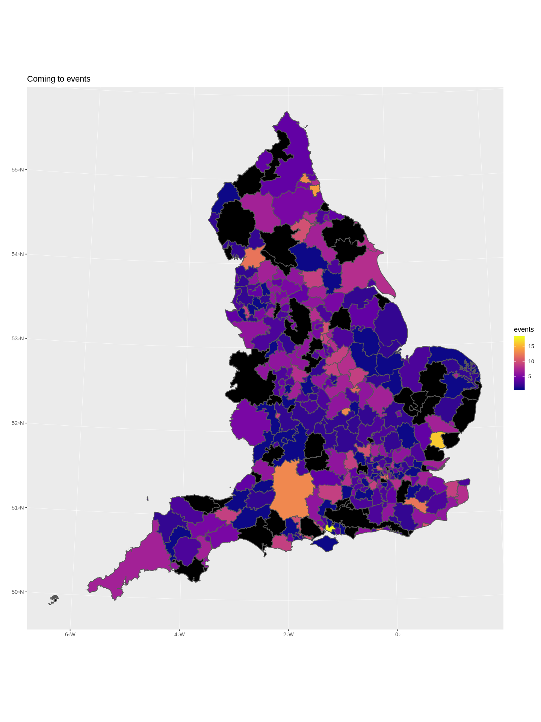

1. The map is useful as a double-check to ensure that we don’t become unwittingly London-centric. It represents a worse case scenario as our CRM system becomes confused by our work with joint councils and (increasingly) our interactions with combined authorities.
2. This map shows where we don’t appear to have seen anyone in the year:

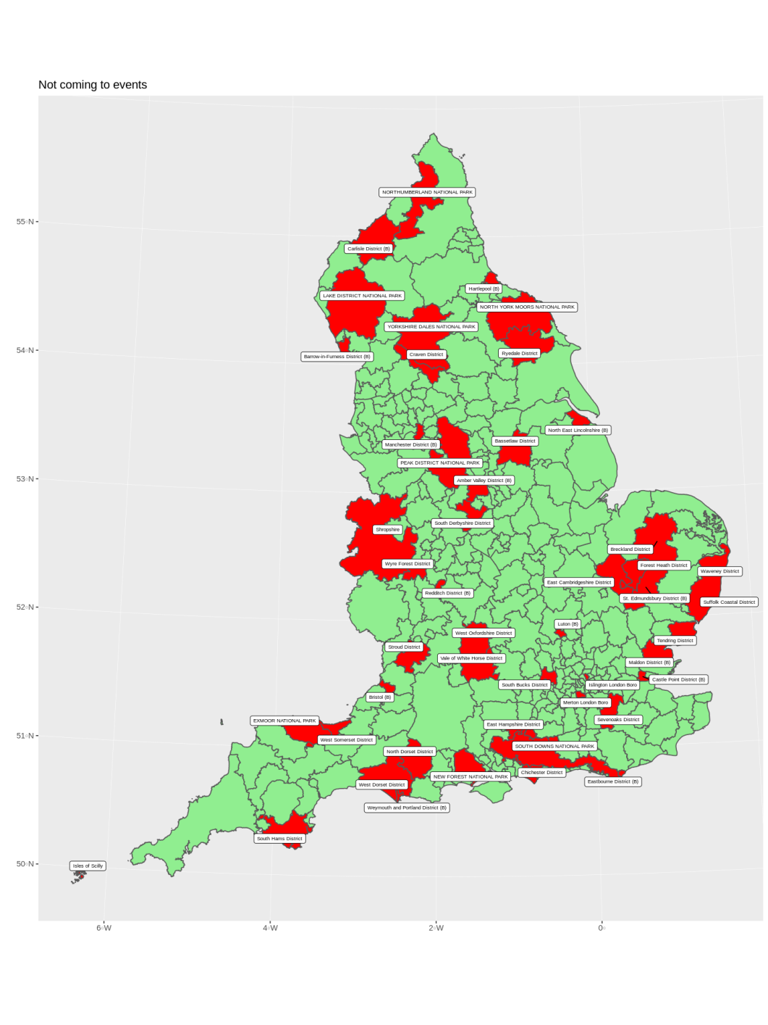

1. It shows that we did not interact much with the National Parks (who mostly don’t have much interest in the housing delivery agenda). Other councils in this list have received other sorts of support from PAS.
2. We have continued to operate a strong peer network, the knowledge hub online resource and our monthly bulletin reaches all local planning authorities.

Outcome measures

1. We are required to deliver against a set of outcome measures as part of the term of the grant agreement. They are accepted to be difficult to capture - both because some of them are too long-term to capture in a year-long assessment and also because some of the outcomes have many more underlying drivers than the PAS programme.

|  |  |  |
| --- | --- | --- |
| Improving policy-making and infrastructure provision | The number of authorities within the target groups that producing ‘sound’ plans is increased.  The number of authorities within the target groups without an up to date plan decreases. | This measure has not been tracked. The NPPF change to 5 years had a massive impact on plans “up to date” |
| Improving decision-making and delivery | All councils are clear what an action plan should contain  Good coverage of HDTAPs  DM performance improves  Shale training | Action plan pilots and guide produced.  HDTAPs not due until August  DM performance evaluated: 100% say support helped improve performance  Shale 100% of members say improved |
| Communication update and reform | At least 85% of attendees are confident about reform  At leas 85% agree that PAS helped them improve the monitoring of delivery pipeline | 97.5% of delegates said they were more confident  90% of delegates said monitoring improved |

Programme for 2019-20

1. We have an agreed high level programme of work signed for 2019-20 which is largely a continuation of 2018-19. However there is less focus on events showcasing reform and providing updates and more on helping councils respond to the policies.



1. To act against optimism bias we overprogramme slightly which is why the programme adds up to more than £1m.
2. In addition to the core grant we will continue to provide commercial services where appropriate and deliver the one-off strategic planning grant work.

Outlook

In the short term

1. Other ideas and pieces of work we are considering at present, based on conversations with practitioners and colleagues in the LGA include:
   1. An update to our 5 year land supply guide, factoring in recent changes to the definition of “deliverable” as well as the new standard method of calculating local housing need.
   2. Helping support a “back to planning” project run along similar lines to a very successful “back to social work” scheme

In the longer term

1. For the majority of the last few years PAS has been a programme renewed on an annual basis. This promotes a responsive and flexible attitude, but makes it difficult to think, act and recruit in the longer term.
2. MHCLG are aware of the issue, and especially of the difficulty attracting and retaining staff in such an unsettled environment. During 2019-20 they propose carrying out a review of the PAS programme with the intention of setting up a multi-year settlement.
3. It is not clear whether this review will lead to a longer-term outlook for a broadly similar programme or something more fundamental. It is possible that PAS could be reconfigured to help deliver the objectives of the Planning Green Paper.